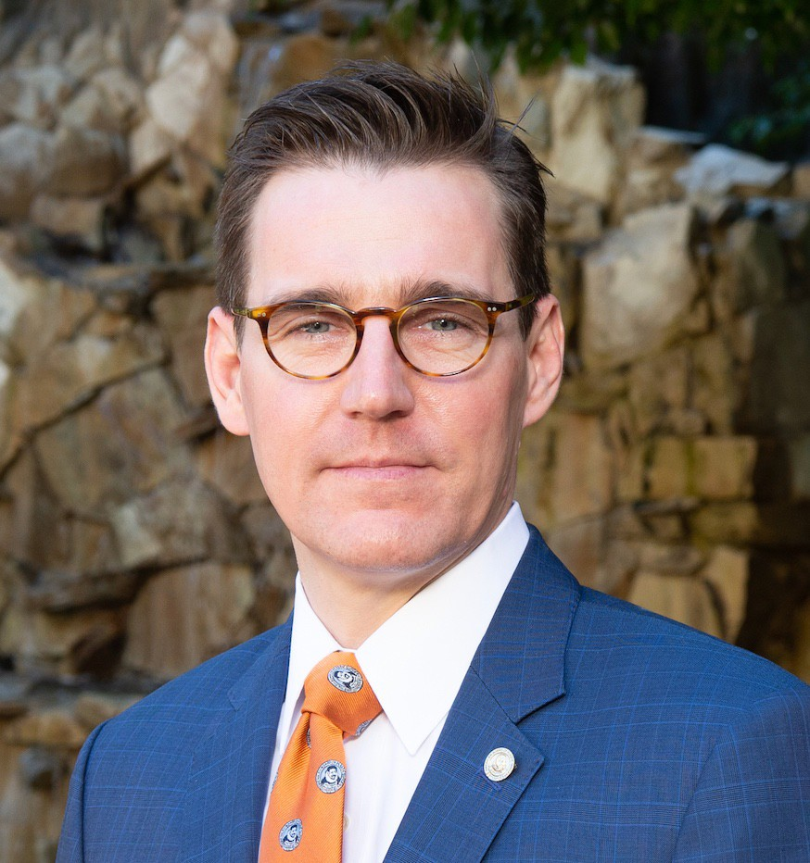

Joseph E. Losee, MD, FACS, FAAP

Vice Dean for Faculty Affairs, University of Pittsburgh School of Medicine Dr. Ross H. Musgrave Endowed Chair in Pediatric Plastic Surgery Executive Vice Chair, Department of Plastic Surgery

University of Pittsburgh Medical Center

Dr. Joseph E. Losee serves as the Vice Dean for Faculty Affairs at the School of Medicine and is the Dr. Ross H. Musgrave Endowed Chair of Pediatric Plastic Surgery and Executive Vice Chair of the Department of Plastic Surgery at the University of Pittsburgh Medical Center. He is the Co-Chair of the UPMC Health System Physician Wellness Initiative. He served as Chief of the Division of Pediatric Plastic Surgery at Children’s Hospital of Pittsburgh of UPMC for 20 years (2003-2023). As well, Dr. Losee served as the Vice-Chair of the Pennsylvania State Board of Medicine.

Dr. Losee sat on the American Board of Plastic Surgery for seven years and was Chair of the Board during his final year (2018-2019). In 2020, he served as President of Plastic Surgery’s umbrella National Society, the American Society of Plastic Surgeons, and currently is President of the American Society of Maxillofacial Surgery. He is Past-President of the: American Council of Academic Plastic Surgeons, American Society of Craniofacial Surgeons, Northeastern Society of Plastic Surgeons, Robert H. Ivy Society, Ohio Valley Society of Plastic Surgeons, and the American Society of Pediatric Plastic Surgery.

He has edited 6 textbooks including, ***“Comprehensive Cleft Care”***, the authoritative text on Cleft Surgery in its second edition, and **“*Pediatric Plastic Surgery”***, of the multi-volume “***Plastic Surgery***” text. Dr. Losee has authored over 245 peer-reviewed articles and 40 book chapters. His has performed federally funded research (DOD) on bone and suture regulation, as well as skull defects in infants; and, he has been Co-PI of an NIH RO1 investigating the treatment of ear disease in cleft palate patients. He has given over 175 invited lectures and has been a visiting professor at over 50 national and international universities.